Open road tolling system with ANPR technology enacting no toll booth System
N.vishwanathan¹, S.Nithish², K.Yashwanth³, S.yuvaraj⁴ Gunavathie M A⁵
IInd year B.TECH student, DEPT. of IT, Panimalar Engineering College, Chennai, TN, India^{1,2,3,4}
Assistant professor, DEPT. of IT, Panimalar Engineering College, Chennai, Chennai, TN, India⁵
1)vishwanathan247@gmail.com
2)nithish3006@gmail.com
3)yashwanth.kuppuraj05@gmail.com
4)yuvarajsenguttuvan12@gmail.com
5)gunavathie.ap@gmail.com
Abstract. Most of the current toll systems lie under the implementation of RFID (Radio Frequency Identification) technology as the vehicles are equipped with the stickers called as FASTag that automatically scans the considerable amount from the respective vehicles and also it never excluded the manual cash collection from vehicles. However, the vehicles must wait in the queue whether it is a manual or FASTag. The ideology of the project is to diminish the road traffic by enacting the ANPR (Auto Number Plate Recognition) system. Such technology ensures efficient road tax collection implementing “NO TOLL BOOTH” system. The objective of this paper is to articulate the cost, time efficient as well as error free mechanism of the ANPR technology.

INTRODUCTION:
As the evolution of IOT has become more these days, the GPS (Global positioning system) which is one of the most sophisticated device which is a space-based navigation system that Identify an object in the ground with the help of the satellite. The GPS transmits the information of a particular object to the GPS receiver via radio signals. These signals contain the exact information like coordinates, moving speed, time, location also the weather.
It is one of the key components that should be implemented for the ANPR along with OBU (On-board unit) which is an electronic device installed in the vehicle used to record the driving data so the amount based on the vehicle is determined. Also it records the traffic density and driving data.
The OBU gets the correct location from the satellite constellation and the driving data is sent via cellular network to proxy servers. These proxy servers collect the data and forward it to the e-toll booth system in where the data of the respective vehicle is processed to determine the amount to pay. Once the process has been finished, the respective amount can be debited directly from the bank account of the owner of the respective vehicles.as the number of vehicles got increasing rapidly from day to day, it is difficult to handle such large number of vehicles in the traditional toll boothing system. This GPS based e-toll system completely the concept of this traditional system as some region in the highways should be allotted as toll region inside where cameras are used for recording the number plate of every vehicles to identify what are all the vehicles has gone through the zone. The OBU sends the driving data once the vehicle passes into the region to the E-booth where the amount is calculated and charged from the respective directly from their bank account. However, at the end of the toll region, there would be a single or two lane manual tolls in to manually charge in case of there is a defect in the OBU or the insufficiency in their bank account or there may be some technical error etc…

RELATED WORKS:
The title is “a systematic review of electronic toll collection systems” Khorshadul Haque Zoy1, Mahir Shahrier1, Armana Sabiha Huq [1],published on 2020 at google scholar that Automatic Toll Collection (ATC) is becoming increasingly prevalent as it replaces Traditional method of Toll sysem (MTC-Manaual toll collection system). The Automatic Coin Machines became the foundation for ATC, accepting coins and tokens issued by the head office. This automated approach minimizes transaction times, processing delays, and operational expenses, as it eliminates the need for drivers to wait at toll booths for transactions.

Sharpe et al [2], (1996) and Salunke et al. (2013) have emphasized the advantages of ATC, highlighting its efficiency and cost-effectiveness over manual methods. Another technology, Automatic Number Plate Recognition system (ANPR), uses image recognition to read vehicle registration plates from images. ANPR is widely employed by law enforcement agencies globally for tasks such as verifying registered vehicles, identifying unregistered or stolen vehicles. It can also capable of monitoring over speeding, making tracking the vehicles more accurate.

Goyal et al[3], (2016) and Ajanthan et al. (2013) have extensively discussed the applications and benefits of ANPR in law enforcement. “Barcode-based Electronic Toll Collection (ETC)” involves pasting a barcode on the vehicle, which is scanned by laser scanner as the vehicle passing through the toll booth. This method, though simple and traditional, serves the same purpose as a standard electronic tolling DSRC device.

Sanchit et al [4], (2014) have provided insights into “barcode-based ETC” and its functionality.Radio-frequency identification (RFID) based ETC employs an In-vehicle unit (IVU) with an RFID reader on the front windshield. This unit contains a cash card for toll payment and can be either prepaid or postpaid.

Chattoraj et al[5], (2017) discuss the cost-effectiveness of “RFID-based ETC” compared to other technologies. “Dedicated Short Range Communication system (DSRC)” based ETC utilizes short to medium-range wireless communication in the 5.9 GHz bandwidth. This technology, initially used in Japan and Europe in 2003, offers additional features such as blind spot warnings and traffic data collection.

Anowar et al[6], (2016) delve into the functionalities and advantages of DSRC-based ETC. “Global Navigation Satellite System” based tolling relies on GPS and GMS for a user pays tolling method. This technology has been successfully implemented in Germany.

Numrich et al [7], (2012) provide insights into GNSS-based tolling and its applications. Cell Phone Tolling introduces an advanced method of toll collection. An electronic chip is installed in a vehicle, enabling communication establishment from cellular towers to the electronic chip determining the type of vehicle travelled. In summary, the evolution of toll collection methods encompasses various technologies, each offering unique advantages and applications in improving efficiency, reducing costs, and enhancing overall transportation systems.

TECHNOLOGIES INVOLVED:
The chosen microcontroller for the project was the Raspberry Pi 2, selected based on its speed of processing, capabilities as a mini server and the methods of communication. Running on the Raspberry PI OS (Raspbian OS), which is Debian-based and optimized for Raspberry Pi hardware, was a strategic decision due to its capability of performing various tasks like its extensive collection of mature packages and pre-compiled software. To initiate the system, The Raspbian image was installed onto a 32 GB SD card and inserted into The Raspberry Pi-2 microcontroller for loading. The Adafruit Ultimate GPS Hat module was utilized as a GPS module in the project. Prior to incorporating the GPS module, adjustments were made to the microcontroller boot options within The cmdline.txt and inittab documents to facilitate Connectivity to both the Rx and Tx pins for receiving GPS data . In order to streamline the processing of raw serial data from the GPS module for programming tasks, a technology called “Global Positioning System Daemon (GPSD)” package was set up and initialized .This package translated the raw serial data into a system of variables, simplifying data processing.
Alongside GPS functionality, a 16 × 2 type character electronic LCD module was incorporated into the system for delivering notifications about toll location and pricing information. The LCD module was connected to the Raspberry Pi 2 microcontroller using GPIO pins and the Inter-Integrated Circuit (I2C) protocol for communication. The I2C kernel in the microcontroller was installed to allow access to the LCD module. The essential steps for the proper functionalities were the configuration of I2C settings and enabling the secondary I2C pins on the microcontroller. To provide user alerts, a speaker was included and linked to the AUX jack of the microcontroller. Notification audio files stored in the /home/pi/tonido/ folder were transmitted through the analog jack of the microcontroller by setting the output to high. Finally, the implementation involved creating multiple structured query language (SQL) based database management systems for the highway toll collection system.
These databases were formulated to save toll destination details and track user travel history. The integration of RDBMS was facilitated by deploying the SQLite application on the microcontroller. This allowed efficient data management and retrieval within the toll collection system/In summary, the project integrated various hardware components and software solutions, leveraging the capabilities of the Raspberry Pi 2 microcontroller to create a GPS-based highway toll collection system with LCD notifications, user alerts, and structured SQL databases for comprehensive data management enhance the accuracy of GPS positioning by compensating for positioning errors.

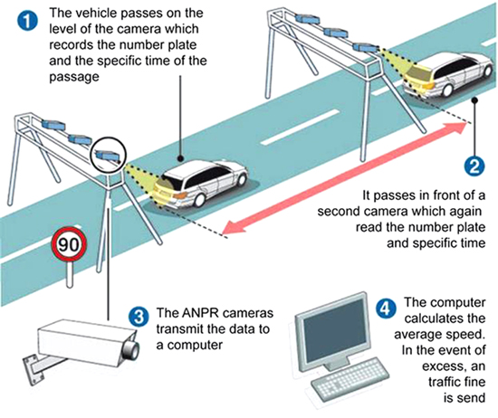
(a) Fig.1 Demonstration of ANPR system

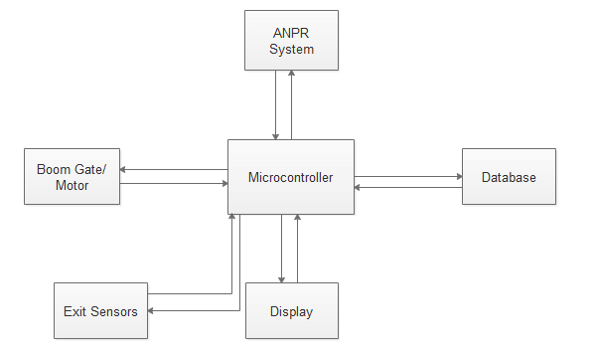
(b) Fig.2 Schematic representation of ANPR

ON-BOARD UNIT (OBU) COMPONENTS:

1. INTEGRATED GPS AND DEAD RECKONING (DR) POSITIONING MODULE:

The OBU incorporates a positioning module that combines Integrated GPS and Dead Reckoning (DR) technology. DR is utilized to position the GPS error comphensation.

2. GLOBAL SYSTEM FOR MOBILE COMMUNICATION BASED (GSM) MODULE:
The OBU communicates with the control room by establishing a dedicated Virtual Private Network (VPN) based on GPRS system. This facilitates secure and efficient data exchange between the OBU and he central system.

3. MICRO-PROGRAMMED CONTROL UNIT (MCU):
Responsible for running the GPS client program and coordinating the operation of all OBU modules, the Micro-programmed Control Unit acts as the central processing unit for the OBU.

4. SMARTCARD MODULE:
Vehicle drivers have the option to use either bank account or FASTag for toll payment. This module also supports security based operations.

5. HUMAN INTERFACING:
The OBU is equipped with a user interface that provides real-time information on the OBU status, vehicle details, and the remaining balance on the FASTag.

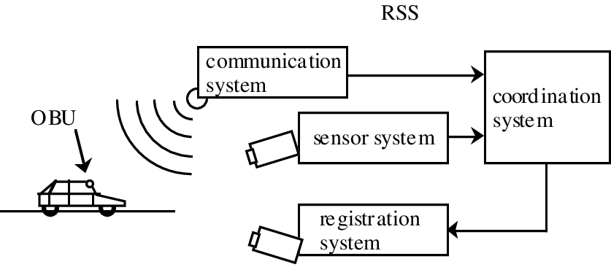
(c) Fig.4 schematic diagram of working of OBU

6.WORKING PRINCIPLE OF THE OBU:
The highways are allocated a particular range of distance for the toll RADAR region. The driving data and the other metadata along with coordinates are stored in the chip’s memory. As the vehicle enters a toll RADAR zone, the Integrated GPS module's coordinates are being authorized and verified with the virtual coordinates. Matching coordinates mark the section, and the OBU calculates the payable toll based on vehicle and fee rates. Through the GSM module, the OBU sends toll based bill and data to the office as it receives the information from OBU and charges the respective amount.

7. RESOLVING TECHNICAL CONFLICTS:
Technical conflicts occur usually when it comes to a software solution. Major problems like insufficient balance and or unexpected technical errors and exceptions may arise. In the case, the manual booth comes into the play.
However this manual booth’s count was reduced by our idea but, the manual booth is used as an Auxiliary method to face these consequences. Also the count of the booths are few as a maximum of two is enough for generally or The respective government of the geographical area can decide the number of booths based upon their count of vehicles and road size etc…
Once the OBU has received the amount to be paid for that particular vehicle, the transaction is held via FASTag or our bank account. In case of insufficient balance or errors, the OBU sends the error message/insufficient message to the servers so that the organization knows that the person is supposed to pay the amount manually.

VARIOUS ENFORCEMENT SYSTEM TECHNOLOGIES INVLOVED:

1. FIXED ENFORCEMENT:
Monitoring stations along the roads will capture the number plates entering the enforcement region. Automatic license plate recognition (OCR) is employed to recognize license plate numbers in real-time.
Dedicated short range communication (DSRC) module reads the particular vehicle’s OBU status information. If matched and OBU status is usual, images are deleted. In case of abnormal or undefined situations, the data of the particular vehicle is sent to the head office database for handling such cases. If the system doesn't able to recognize the particular vehicle’s OBU, then the vehicle is subjected to pay the amount in tollgate by using manual toll collection.

2. VEHICLE’S MOVING ENFORCEMENT:
Government office use DSRC scanning vehicles to read data from OBU and fetching the information of passing vehicles which is being registered. By accessing the registered user database, if the actual information doesn't match the information in the database, the vehicle is redirected for violation checking process.
In summary, the OBU components work in tandem to ensure accurate toll collection, with the enforcement system employing both fixed and moving strategies to handle violations effectively. The integrated technologies create a comprehensive tolling system that balances convenience for users and stringent enforcement measures.

LIMITATIONS OF ENFORCEMENT:
According to our Indian laws, Higher authorities like President, Vice president, Cabinet ministers, High court judges, Foreign dignitaries, Defence departments(Air force, Navy, army),Emergency departments like Ambulance, Fire Extinguisher and Police patrol jeeps are exempt for toll payment.
However, the OBU cannot classify these based on categories. To handle the conflict, a separate database should be maintained for those vehicles. So that the database should be capable of identifying the exempt vehicles so only the entry should be inserted in the database but it doesn’t proceed for payment related issues.

CONCLUSION:
In conclusion, the implementation of an Open Road Tolling System utilizing ANPR (Automatic Number Plate Recognition) technology has proven to be a transformative approach in the realm of toll collection. The seamless and efficient nature of this system not only eliminates the need for traditional toll booths but also enhances the overall traffic flow and user experience. By leveraging advanced technology, such as ANPR, we can achieve a more streamlined and automated tolling process that significantly reduces congestion, travel time, and environmental impact. This study has delved into the various advantages of the proposed system, ranging from increased accuracy in toll collection to the potential for integration with smart transportation systems. Moreover, the cost-effectiveness and adaptability of the Open Road Tolling System make it a viable solution for modernizing toll collection infrastructure.
As we move towards the future of transportation, the integration of cutting-edge technologies like ANPR in tolling systems not only addresses existing challenges but also sets the stage for a more connected and efficient transportation network. The elimination of toll booths paves the way for a smoother traffic flow, reducing delays and enhancing the overall mobility experience for commuters. While challenges such as data security and system reliability must be addressed, the benefits presented by an ANPR-based Open Road Tolling System are clear. This research contributes to the growing body of knowledge in intelligent transportation systems and encourages further exploration of innovative solutions to improve the efficiency and sustainability of our transportation infrastructure. The vision of a seamless, no toll booth system is within reach, promising a more convenient and technologically advanced future for toll collection on open roads.

REFERENCES:
- 1.Khorshadul Haque Zoy¹, Mahir Shahrier¹, Armana Sabiha Huq² towards a systematic review of electronic toll collection SYSTEMS on 1st International Conference on Transportation Research 2020 (ICTR 2020)7 –8 December 2020 BRRL, Mirpur, Bangladesh
- 2. Jin Yeong Tan¹, Pin Jern Ker¹*, Dineis Mani¹ and Puvanesan Arumugam¹ towards GPS-based highway toll collection system Institute of Power Engineering, College of Engineering, University Tenaga Nasional, 43000 Kajang, Selangor, Malaysia
- 3. Saijie Lu, Tiejun He, Zhaohui Gao Intelligent Transportation System Research Center Southeast University Nanjing, 210096, China towards Design of Electronic Toll Collection System based on Global Positioning System Technique on 2009 ISECS International Colloquium on Computing, Communication, Control, and Management
- 4. S.Nandhini¹, P.Premkumar² Assistant Professor, Dept. of ECE, Nandha Engineering College, Erode, Tamilnadu, India¹ Assistant Professor, Dept. of ECE, Nandha Engineering College, Erode, Tamilnadu, India² towards Automatic Toll Gate System Using Advanced RFID and GSM Technology on International Journal of Advanced Research in Electrical, Electronics and Instrumentation Engineering(An ISO 3297: 2007 Certified Organization) Vol. 3, Issue 11, November 2014
- 5.Kin Seong Leong, Mun Leng Ng, Member, IEEE, Alfio R. Grasso, Peter H. Cole, "Synchronization of RFID Readers for Dense RFID Reader Environments", International Symposium on Applications and the Internet Workshops (SAINTW’06), 2005
- 6. Manish Buhptani, Shahram Moradpour, "RFID Field Guide - Developing Radio Frequency Identification Systems", Prentice Hall, 2005, pp 7-9, 16-225, 160, 231
- 7. Shi-Cho Cha Kuan-Ju Huang Hsiang- Meng Chang, " An Efficient and Flexible Way to Protect Privacy in RFID Environment with Licenses", IEEE International Conference RFID, April 16-17,2008
- 8. Priyanka Chhoriya1 , Govinda Paliwal2 , Poonam Badhan3 Department of Computer Engineering, Sir Visvesvaraya Institute Of Technology Chincholi, Nasik Tal. Sinnar, Dist-Nasik, Maharashtra.
- 9. Shan Du, Member, IEEE, Mahmoud Ibrahim, Mohamed Shehata,Senior Member, IEEE and Wael Badawy, Senior Member,IEEE,“Automatic License Plate Recognition (ALPR):State of the Art Review”,Available at “ieeexplore.ieee.org” Vol 23, 07 june 2012.
- 10. S Saha,S Basu, M Nasipuri, D K Basu,“License Plate Localization from Vehicle Images: An Edge Based Multi-stage Approach”, in International Journal of Recent Trends in Engineering (Computer Science), Vol 1, No. 1, pp. 284-288,May2009.

